Rogers-Ramanujan Bijections

Paul Hammond, University of Brighton International College

http://www.kic.org.uk/wp-content/uploads/2011/11/UBIC_Logo.jpg

<http://www.kic.org.uk/brighton/>

<http://sro.sussex.ac.uk/view/creators/5315.html>

[p.hammond2@brighton.ac.uk](mailto:p.hammond2@brighton.ac.uk)

**Partitions**



What is a partition?

A **partition** is a sequence of numbers that add up to a given number. There are five partitions of $4$:

(So we say $p\left(4\right)=5$)

$4 = 4 = \left(4\right)$ $So we say$

$$4 = 3+1 = \left(3,1\right)$$

$$4 = 2+2 = \left(2,2\right)$$

$$4 = 2+1+1 = \left(2,1,1\right)$$

$$4=1+1+1+1 =(1,1,1,1)$$

Note; the sequences are non-increasing.

Ferrers diagram:

rows represent entries

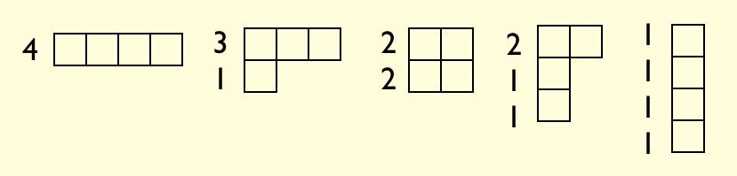

**source:**<http://mathforum.org/mathimages/index.php/Catalan_Numbers>

is the number of partitions of $n$

$$\sum_{n≥0}{p(n)q^{n} = \prod_{i≥1}{\frac{1}{\left(1-q^{i}\right)}}}$$

Definitions.

For complex $a$, $b$, $c$,…, $z$ and $q$ (with $|q|<1$);

$${ \left(z;q\right)}_{n} := \left(1-z\right)\left(1-zq\right)…\left(1-zq^{n-1}\right)$$

$${\left(a,b,c;q\right)}_{∞} :={ \left(a;q\right)}_{∞}{\left(b;q\right)}_{∞}{\left(c;q\right)}_{∞}$$

$${[z;q]}_{∞} := {\left(z;q\right)}_{∞} {\left(z^{-1}q;q\right)}_{∞}$$

$${\left[a,b,c;q\right]}_{∞} := {\left[a;q\right]}_{∞}{\left[b;q\right]}_{∞}{\left[c;q\right]}_{∞}$$

## Generalized Rogers-Ramanujan Bijections

**By**David M. Bressoud and Doron Zeilberger

[**http://core.ac.uk/display/21075956**](http://core.ac.uk/display/21075956)

The number of partitions of $n$ where the difference is greater than $1$***is equal to*** the number partitions of $n$ with each part congruent to $±1$ mod $5$ (i.e. of the form $5m+1$ or $5m+4$). This result was conjectured in 1913 by Srinivasa Ramanujan – it had been proved in 1894 by L. J. Rogers.

**Example $n = 10$**



As a $q$-series identity:

$$\sum_{s≥0}{\frac{q^{s^{2}}}{{\left(q;q\right)}_{s}} = \prod_{i≥0}{\frac{1}{\left(1-q^{5i+1}\right)\left(1-q^{5i+4}\right)}}}$$

**($s^{2} = 1+3+5+…2s-1$)**

$$• • • • •$$

$$• • •$$

$$•$$

The $q$-binomial coefficients:

$$\left[\begin{matrix}A+B \\ A\end{matrix}\right] = \frac{{\left(q;q\right)}_{A+B}}{{\left(q;q\right)}_{A}{\left(q;q\right)}_{B}}$$

These generalise binomial coefficients,

Lim***q*->1**

And $\left[\begin{matrix}A \\ B\end{matrix}\right]$ is the generating function for partitions

(bounded by having) first part $≤A$,

and number of parts

